GLENVIEW

‘We kind of went about this very rushed and it’s very apparent’ Glenview neighbors on Willows Crossing
By Karie Angell Luc
Pioneer Press
•
Sep 11, 2022 at 11:48 pm
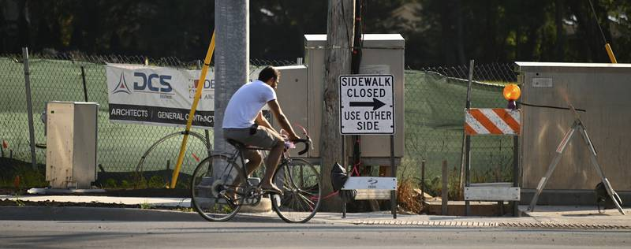
On Sept. 8, 2022, a cyclist remains on the side of the road along Willow Road where a sidewalk is closed. Photo taken at the corner of Pfingsten and Willow Roads. (Karie Angell Luc / Pioneer Press)
Despite some no votes, the Glenview Board of Trustees went ahead with changes to municipal codes in business districts within neighborhoods.
What does that mean to Glenview residents along Willow and Pfingsten Roads who live near property that could be developed by applicant GW Properties under revised B1 zoning within neighborhoods?
Several residents attending the Board of Trustees meeting on Sept. 6 were concerned that ordinances approving text amendments to particularly the B1 zoning code could make it easier for the developer to be granted a business district wish list (along the 2600 block of Pfingsten Road) at the southwest corner of Willow and Pfingsten.
The group is upset that a majority of trustees on Sept. 6 took favorable cues from Glenview’s New Development Commission, resulting in modifying wording to codes via ordinance which redefine what could possibly go into B1 zoned districts along residential.
That corner was formerly covered with heavy foliage. To the ire of neighbors, trees were cleared and much of the land was opened to full sun as neighboring homes abruptly lost natural buffers helping to shield noise in what many claim is a high traffic area.
The rude awakening shocked neighbors who further bristled when developers acted to swiftly convert the property to a business/shopping district dubbed Willows Crossing.
But residents fought the developer’s plans and organized, pressing on social media. They created a Facebook group and have a website
https://www.willowpfingstensw.com/.
They have asked neighbors to attend public meetings in force.
There is an Action Network petition against the development at https://actionnetwork.org/petitions/there-is-not-a-community-need-for-commercial-at-willow-and-pfingsten.
As of Sept. 9 (at noon), collected were 282 of a goal of 400 signatures. This petition is directed to the Glenview’s Village Board of Trustees and the New Development Commission.
“There is not a community NEED (in all caps) for commercial at Willow and Pfingsten,” this Internet petition states.
Neighbors stepping up their presence say they plan to attend a New Development Commission meeting this month to present their side and expose problems with the applicant’s development.
Such conflicts, they claim, include in-and-out traffic chaos by potential neighboring businesses such as carpool-causing day care centers. Motorists including parents could come several times a day to drop off or pick up children attending a future day care center, causing queue backups and vehicle fumes impacting local air and the environment.
Brett Hanley of west Glenview addressed the board about the issue during the public comment portion.
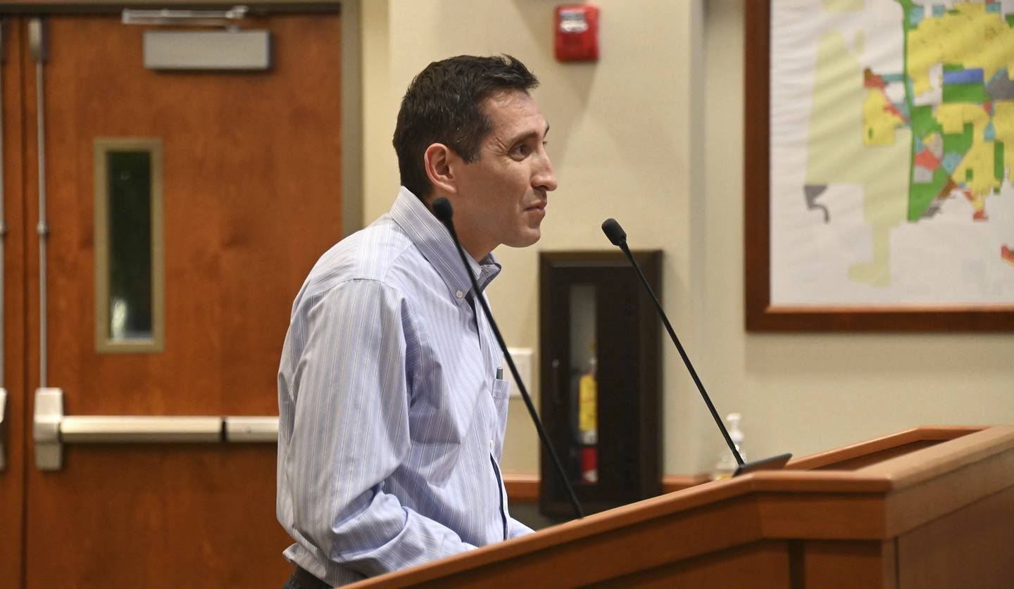
Brett Hanley of Glenview during the three minutes allowed for comments by the public. “I don’t agree with this but I do understand the trustees’ desire,” Hanley said to the board. Image from Sept. 6, 2022. (Karie Angell Luc / Pioneer Press)
“I do understand the intent of the trustees that outdoor uses are desired to be permitted for restaurants and for day cares,” Hanley said to the board.
Accessory use is, “not well defined,” Hanley said, “that we could be inviting uses … that were really not intended, and this could hurt not just immediate adjoining residences to B1, B2, but also business neighbors.
“I don’t agree with this but I do understand the trustees’ desire.”
Hanley pointed out the area is already busy with traffic traveling along Interstate 294, and to NorthShore Glenbrook Hospital, Willowbrook School, Maple School, Plaza del Prado and Glenbrook Marketplace.
To Pioneer Press, Hanley said, “It really impacts the entire community and neighborhood of the Willows neighborhood.
“It really impacts all of west Glenview because it increases traffic conflict, the potential for accidents and real major concerns with traffic pedestrian bicycle flow.
“By introducing all the new traffic from this potential new center, we’re opposing that zoning change,” Hanley said.
Hanley pointed to Glenview’s 2017 comprehensive plan which Hanley felt had the potential for the land in question to become residential.
Hanley said more than one dozen neighboring homes are impacted.
“But if it were to go through,” Hanley said of possible future business district development, “we need to make sure that everything is appropriate for our community and the village.”
Trustees heard about the amount of space required to comfortably separate residential lots from new business development and how neighboring communities such as Northbrook, Deerfield, Highland Park and Wilmette write zoning laws.
Bulk is a concern to Trustee Adam Sidoti.
“Uses in and of themselves may be benign for a particular district but when you bulk them together could have unintended results,” Sidoti said.
Trustee Gina DeBoni said, “I can’t help but wonder that with B1, which is designed to be our most restrictive zoning, that something like what our neighboring communities do doesn’t also make sense for our community,” while also adding, “ … in a most restrictive zone that’s designed to not inhibit residential enjoyment around it.
“Having some sort of setback embedded into B1 I think makes pretty good sense,” DeBoni said.
Glenview neighbor Skip Newman indicated feeling, “very concerned,” and said of the developer, “The fundamental thing is he’s trying to put 20 pounds of potatoes in a 10 pound sack.
“It would be way better to have houses,” Newman said.
“The developer will say anything or do anything to try to convince people to pay no attention to the man behind the curtain over all these obvious flaws.”
West Glenview resident Debbie Liner, who resides on the same street as Hanley, told trustees, “I caution the village to say, we need to be considering this holistically,” Liner said about bulk regulations.
“I think we kind of went about this very rushed and it’s very apparent.”
Karie Angell Luc is a freelancer for Pioneer Press.

