Glenview Plan Commission postpones hearing on contentious proposal amid litigation from residents, IDOT requests
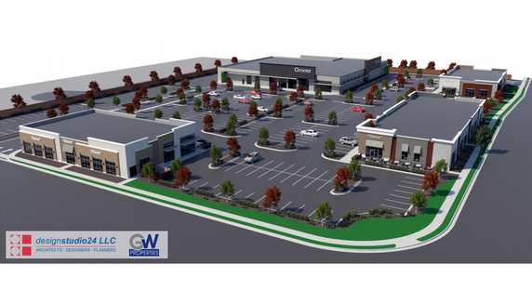
The Glenview Plan Commission has delayed a public hearing scheduled for Thursday, Sept. 26 on a contentious development proposal at the southwest corner of Willow and Pfingsten roads. The commission announced its decision to delay the hearing amid a request for revisions from IDOT and litigation from a group of Glenview residents. Rendering courtesy of the Village of Glenview

Jason Addy, Editor
1:17 pm CDT September 26, 2019

The Glenview Plan Commission has delayed tonight’s public hearing on a contentious development proposal for two weeks after a group of Glenview residents sued the Village Tuesday, Sept. 24, to block the hearing from moving forward.
The residents then filed an emergency motion Wednesday, Sept. 25, seeking a temporary restraining order that would block the Glenview Plan Commission from “proceeding with any submissions, reviews, meetings, recommendations and approvals” related to the Hart property that is located at the southwest corner of the intersection of Willow and Pfingsten roads.
After the two legal filings, the commission moved its third public hearing on GW Properties’ proposal to create more than 63,000 square feet of new retail space on the property to Thursday, Oct. 10, according to Jeff Rogers, the Village’s planning manager.
Cook County Circuit Court Judge Pamela McLean Meyerson is set to consider the residents’ motion for a temporary restraining order this afternoon at a hearing scheduled for 3:30 p.m. at the Richard J. Daley Center in downtown Chicago.
GW Properties requested the meeting be postponed to revise the “access design” of its proposal in response to concerns from the Illinois Department of Transportation, Rogers told The Lantern, adding the delay is unrelated to the pending litigation.
Rogers said he expects GW Properties to submit its revised plan during the next week, at which point it will be posted online for residents to view before the Oct. 10 public hearing.
Julie Tappendorf, the attorney for the Village of Glenview, said village officials “are evaluating the claims” in the lawsuit and will soon file a response.
Tappendorf said the Village’s concern with the litigation is that it could stop the Village’s “public process” to vet whether a development is appropriate for a property.
“This type of motion would stop the Village from following its own process,” Tappendorf said.
“It doesn’t benefit the Village; it doesn’t benefit the developer; it doesn’t benefit the residents.”
A group of 16 residents, who all live near the Hart property at the southwest corner of the intersection, filed a lawsuit Tuesday asking the court to invalidate a 1988 Glenview zoning ordinance at the heart of the current proposal from GW Properties.
In the lawsuit, the group of residents claims the Village never notified residents before public hearings in March 1988, when the Glenview Plan Commission and Village Board debated and approved an ordinance to rezone the Hart property from a residential plot to a B-1 limited business district if a developer submitted a proposal to build on the property.
By law, the Village was required to publish a notice of a public hearing for the proposed ordinance 15-30 days ahead of the hearing on March 8, 1988.
The Village of Glenview has a certificate of publication on file verifying the notice was published 17 days before the meeting in the Feb. 20, 1988, edition of The Chicago Tribune.
But according to the residents, who reviewed The Chicago Tribune’s “online archives, the Chicago Public Library’s online and microfilm archives of The Chicago Tribune, and the Glenview Public Library’s microfilm archives of The Chicago Tribune,” no public notice was ever published.
Images of the The Tribune’s Feb. 20, 1998, edition that were included in the emergency motion filed Wednesday show no public notice from the Village of Glenview was published in the Legal Notices section of that paper.
The lawsuit argues the rezoning of the property that was approved in May 2019 should be voided and the zoning should revert back to residential, as the ordinance is invalid.
Residents are asking the court to declare the 1988 ordinance invalid because there was not proper notice to residents before the legally mandated public hearing.
Check back to GlenviewLanternDaily.com for updates to this story.

